**Student & Batch Table – Attendance record**

**SQL Workbench – Wamp server**

* Create a student table with all student details.

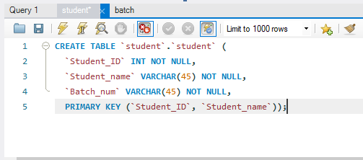

* Create a batch table with multiple batches and its corresponding details. Every batch will contain fields representing students attending the batch on a particular date.

A student will belong to only one batch.

Each batch inside the batch collection will contain multiple students attending the respective batch.

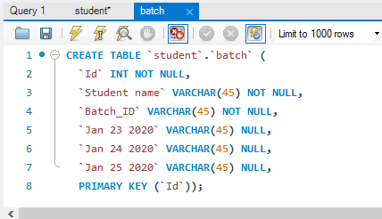

**Questions:**

1. Write a query to insert student details in student table.
2. INSERT INTO `Student`.`student` (`Student_ID`, `Student_name`, `Batch_num`) VALUES ('1', 'Lahari', 'B14');

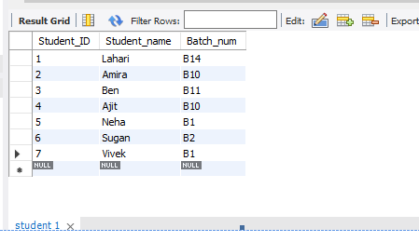

1. Write a query to insert batch details in batch table
2. INSERT INTO `student`.`batch` (`Id`, `Student name`, `Batch_ID`, `Jan 23 2020`, `Jan 24 2020`, `Jan 25 2020`) VALUES ('2', 'Amira', 'B10', 'P', 'A', 'P');

INSERT INTO `student`.`batch` (`Id`, `Student name`, `Batch_ID`, `Jan 23 2020`, `Jan 24 2020`, `Jan 25 2020`) VALUES ('8', 'Riyaz', 'B6', 'P', 'A', 'A');

INSERT INTO `student`.`batch` (`Id`, `Student name`, `Batch_ID`, `Jan 23 2020`, `Jan 24 2020`, `Jan 25 2020`) VALUES ('1', 'Lahari', 'B14', 'P', 'P', 'P');

INSERT INTO `student`.`batch` (`Id`, `Student name`, `Batch_ID`, `Jan 23 2020`, `Jan 24 2020`, `Jan 25 2020`) VALUES ('3', 'Ben', 'B11', 'P', 'P', 'P');

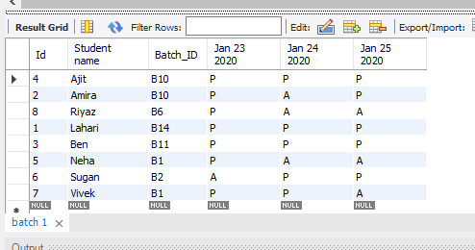

1. Write a query to Mark attendance for the students at respective batch on Jan 23 2020.
2. UPDATE Student.batch

SET `Jan 23 2020` = "A"

WHERE Id = 6;

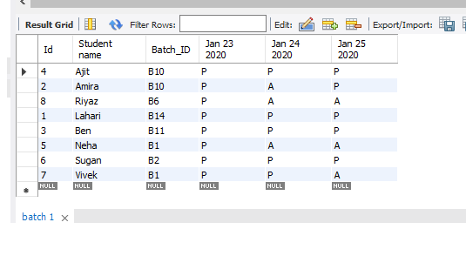

Fig: Before 3rd Query

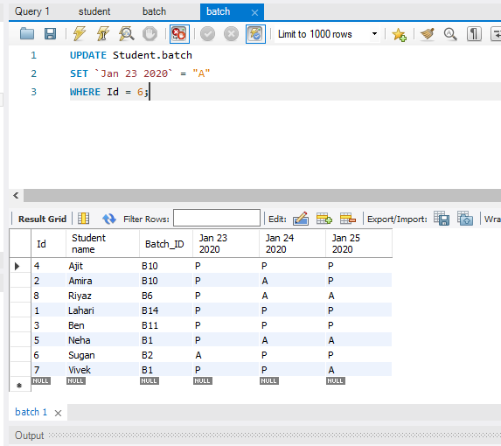

Fig: After 3rd Query

1. Write a query to display the batch details and attendance history of student 1.
2. SELECT `Student_name` , `Jan 23 2020`,`Jan 24 2020`,`Jan 25 2020`

FROM Student.student

INNER JOIN Student.batch

ON student.Student_ID = batch.Id

WHERE `Student_ID` = 1;

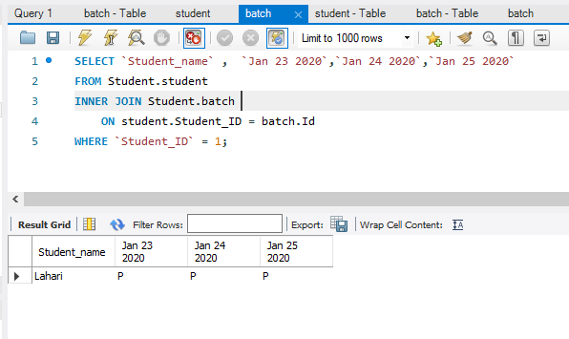

1. Write a sql query to display a table containing students attending batch1 along with their attendance history
2. SELECT `Batch_ID`,`Student_name` , `Jan 23 2020`,`Jan 24 2020`,`Jan 25 2020

FROM Student.batch

INNER JOIN Student.student

ON student.Student_ID = batch.Id

WHERE Batch_ID = "B1";

